The Team

Alimam Diaby

Mike Patterson

Aziz Isamedinov

Carlos Cuevas

Prakriti Rana

Cancer Awareness

* What’s cancer
* Cancer types, stages
* Cancer diagnosis and prediction

Data Sources

Rates of cancer in the US.

<https://gis.cdc.gov/Cancer/USCS/DataViz.html>

Breast Cancer Wisconsin (Original) Data Set

[**https://archive.ics.uci.edu/ml/datasets/breast+cancer+wisconsin+%28original%29**](https://archive.ics.uci.edu/ml/datasets/breast+cancer+wisconsin+%28original%29)

Cancer Incidence in the US by state and race

https://www.kaggle.com/salomekariuki/cancer-incidence-in-the-us-by-

state-and-race#State.csv

United States Cancer Statistics

<https://wonder.cdc.gov/cancer.html>

Breast Cancer

<https://www.kaggle.com/nsaravana/breast-cancer>

MIAS Mammography

<https://www.kaggle.com/kmader/mias-mammography>

Mammography Mass

<https://data.world/uci/mammographic-mass>

Breast Cancer

<https://data.world/uci/breast-cancer>

Breast Cancer Deaths

<https://data.world/brianray/gapminder-breast-cancer-deaths>

What’s Cancer youtube

<https://www.youtube.com/watch?v=ZGJ169HpZqc&feature=youtu.be>

Strategy and Metrics

1. Extract data from CSV
2. Convert data into necessary data sets:
3. Present the connections between respective variables

Data Analysis Tools Plan

Excel- View and Examine data

Python Flask - create routes to visulize data from different views

HTML/CSS- create webpage to view data locally and from a server

JavaScript- create visualizations for users to view and manipulate data

MongoDB- to clean and sort data

Products Produced  
Java driven webpage with user manipulation

Sample Visualizations

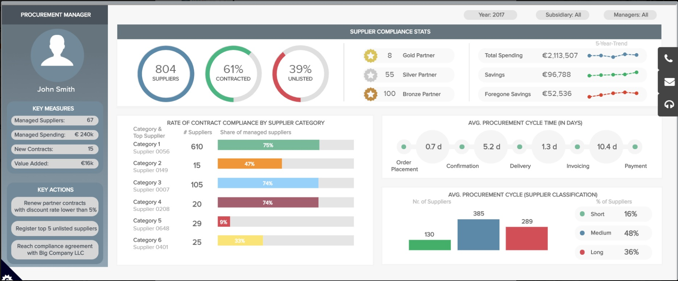

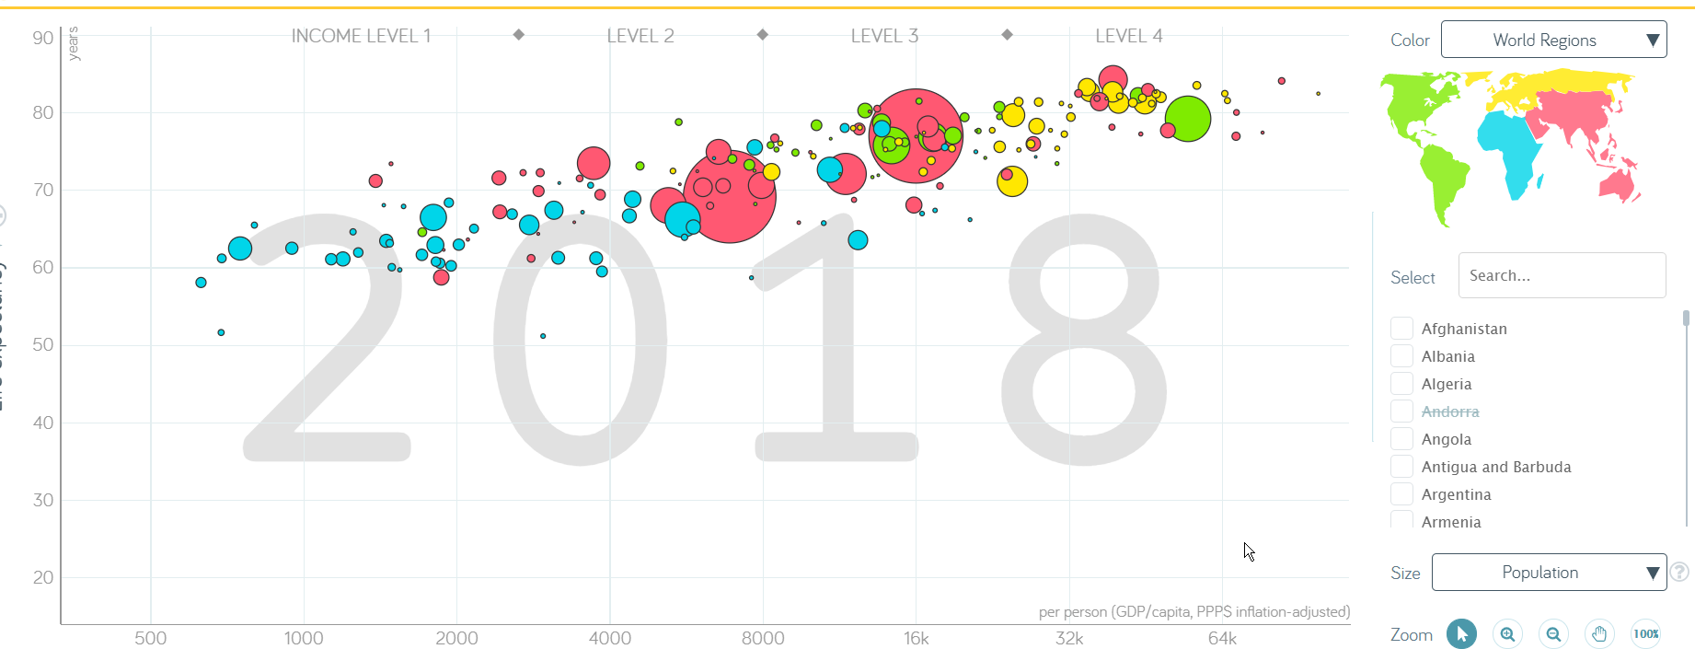

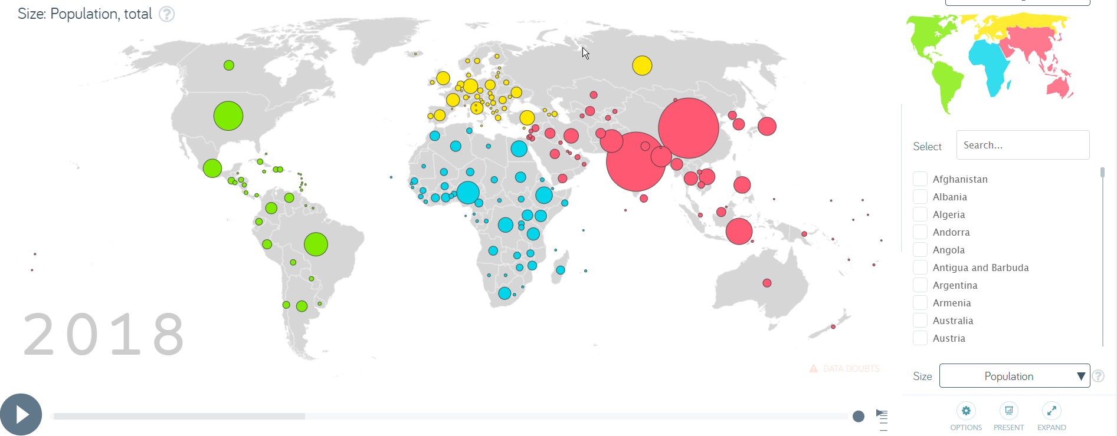

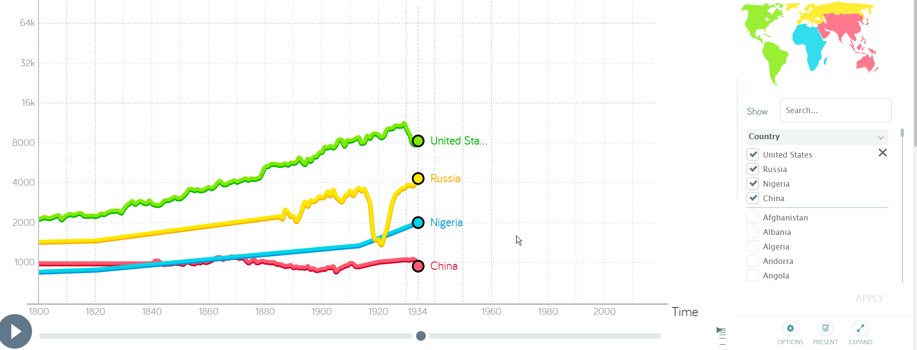

[GitHub Repository](https://github.com/Wittie1986/project2-group1)

Desired Outcome: